Министерство науки и высшего образования Российской Федерации
Муромский институт (филиал)
Федерального государственного бюджетного образовательного учреждения высшего образования
«Владимирский государственный университет
имени Александра Григорьевича и Николая Григорьевича Столетовых»

Факультет ИТР
Кафедра ПИн

ЛАБОРАТОРНАЯ
РАБОТА №5

По Организация баз данных

Руководитель
Быков А.А.
(фамилия, инициалы)

(подпись) (дата)

Студент ПИн - 121
(группа)
Ермилов М.В.
(фамилия, инициалы)

(подпись) (дата)

Муром 2023
Лабораторная работа №4

Тема: Создание базы данных средствами SQL

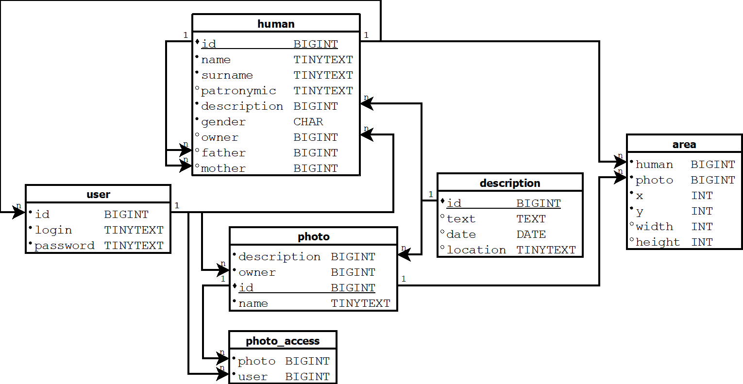
Рисунок 1 - схема базы данных

Ход работы

Листинг кода по заданию, написанных на СУБД MySQL:
CREATE TABLE IF NOT EXISTS `user` (
`id` bigint(20) unsigned NOT NULL,
`login` tinytext NOT NULL,
`password` tinytext NOT NULL,
UNIQUE KEY `login` (`login`) USING HASH,
KEY `FK_user_human` (`id`) USING BTREE,
CONSTRAINT `FK_user_human` FOREIGN KEY (`id`) REFERENCES `human` (`id`) ON DELETE NO ACTION ON UPDATE NO ACTION
) ENGINE=InnoDB DEFAULT CHARSET=utf8mb4;

CREATE TABLE IF NOT EXISTS `human` (
`id` bigint(20) unsigned NOT NULL AUTO_INCREMENT,
`name` tinytext NOT NULL,
`surname` tinytext NOT NULL,
`gender` tinyint(3) unsigned NOT NULL COMMENT '2 - неопределен\r\n1 - мужчина\r\n0 - женщина',
`mother` bigint(20) unsigned DEFAULT NULL,
`father` bigint(20) unsigned DEFAULT NULL,
`description` bigint(20) unsigned NOT NULL,
`owned` bigint(20) unsigned DEFAULT NULL,
`date_death` bigint(20) DEFAULT NULL,
PRIMARY KEY (`id`),
UNIQUE KEY `id` (`id`),
KEY `FK_human_human` (`mother`),
KEY `FK_human_human_2` (`father`),
KEY `FK_human_description` (`description`),
KEY `FK_human_user` (`owned`),
CONSTRAINT `FK_human_description` FOREIGN KEY (`description`) REFERENCES `description` (`id`) ON DELETE NO ACTION ON UPDATE NO ACTION,
CONSTRAINT `FK_human_human` FOREIGN KEY (`mother`) REFERENCES `human` (`id`) ON DELETE NO ACTION ON UPDATE NO ACTION,
CONSTRAINT `FK_human_human_2` FOREIGN KEY (`father`) REFERENCES `human` (`id`) ON DELETE NO ACTION ON UPDATE NO ACTION,
CONSTRAINT `FK_human_user` FOREIGN KEY (`owned`) REFERENCES `user` (`id`) ON DELETE NO ACTION ON UPDATE NO ACTION
) ENGINE=InnoDB AUTO_INCREMENT=1 DEFAULT CHARSET=utf8mb4 ROW_FORMAT=DYNAMIC;

CREATE TABLE IF NOT EXISTS `human_access` (
`user` bigint(20) unsigned NOT NULL DEFAULT 0,
`human` bigint(20) unsigned NOT NULL DEFAULT 0,
KEY `FK_human_access_human` (`human`),
KEY `FK_human_access_user` (`user`),
CONSTRAINT `FK_human_access_human` FOREIGN KEY (`human`) REFERENCES `human` (`id`) ON DELETE NO ACTION ON UPDATE NO ACTION,
CONSTRAINT `FK_human_access_user` FOREIGN KEY (`user`) REFERENCES `user` (`id`) ON DELETE NO ACTION ON UPDATE NO ACTION
) ENGINE=InnoDB DEFAULT CHARSET=utf8mb4;

CREATE TABLE IF NOT EXISTS `description` (
`id` bigint(20) unsigned NOT NULL AUTO_INCREMENT,
`content` text NOT NULL,
`date` bigint(20) DEFAULT NULL,
`location` tinytext DEFAULT NULL,
PRIMARY KEY (`id`),
UNIQUE KEY `id` (`id`)
) ENGINE=InnoDB AUTO_INCREMENT=1 DEFAULT CHARSET=utf8mb4 ROW_FORMAT=DYNAMIC;

CREATE TABLE IF NOT EXISTS `photo` (
`id` bigint(20) unsigned NOT NULL AUTO_INCREMENT,
`owned` bigint(20) unsigned NOT NULL,
`description` bigint(20) unsigned NOT NULL,
`url` tinytext NOT NULL,
PRIMARY KEY (`id`),
UNIQUE KEY `id` (`id`),
KEY `FK_photo_user` (`owned`),
KEY `FK_photo_description` (`description`),
CONSTRAINT `FK_photo_description` FOREIGN KEY (`description`) REFERENCES `description` (`id`) ON DELETE NO ACTION ON UPDATE NO ACTION,
CONSTRAINT `FK_photo_user` FOREIGN KEY (`owned`) REFERENCES `user` (`id`) ON DELETE NO ACTION ON UPDATE NO ACTION
) ENGINE=InnoDB DEFAULT CHARSET=utf8mb4;

CREATE TABLE IF NOT EXISTS `photo_access` (
`user` bigint(20) unsigned NOT NULL,
`photo` bigint(20) unsigned NOT NULL,
KEY `FK_photo_access_user` (`user`),
KEY `FK_photo_access_photo` (`photo`),
CONSTRAINT `FK_photo_access_photo` FOREIGN KEY (`photo`) REFERENCES `photo` (`id`) ON DELETE NO ACTION ON UPDATE NO ACTION,
CONSTRAINT `FK_photo_access_user` FOREIGN KEY (`user`) REFERENCES `user` (`id`) ON DELETE NO ACTION ON UPDATE NO ACTION
) ENGINE=InnoDB DEFAULT CHARSET=utf8mb4;

CREATE TABLE IF NOT EXISTS `zone` (
`photo` bigint(20) unsigned NOT NULL,
`human` bigint(20) unsigned NOT NULL,
`x` int(11) NOT NULL DEFAULT 0,
`y` int(11) NOT NULL DEFAULT 0,
KEY `FK_zone_photo` (`photo`),
KEY `FK_zone_human` (`human`),
CONSTRAINT `FK_zone_human` FOREIGN KEY (`human`) REFERENCES `human` (`id`) ON DELETE NO ACTION ON UPDATE NO ACTION,
CONSTRAINT `FK_zone_photo` FOREIGN KEY (`photo`) REFERENCES `photo` (`id`) ON DELETE NO ACTION ON UPDATE NO ACTION
) ENGINE=InnoDB DEFAULT CHARSET=utf8mb4;

INSERT INTO description (text, date, location) VALUE ("Взятие Берлина, войсками СССР", "08-05-1945", "Берлин")
INSERT INTO description (text, date, location) VALUES ("Путешествие по Крымскому полуострову", "12-07-1998", "Крым"), ("Путешествие по Югу", "23-07-1998", "Сочи")

UPDATE description SEY date="09-05-1945", text="Капитуляция Германии" WHERE id = 1

DELETE FROM description WHERE id = 1

